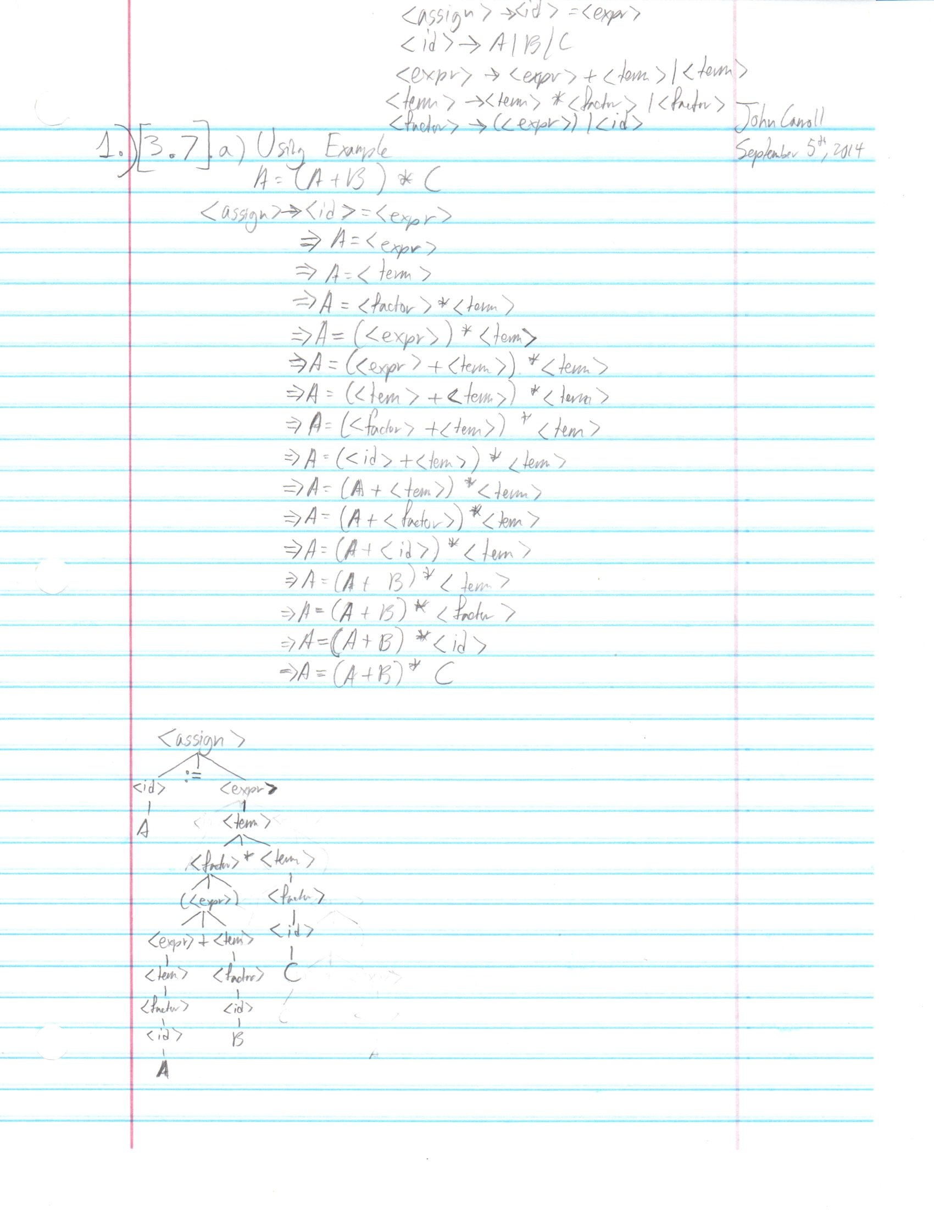Homework 2  
John Carroll  
(1. 20pts) Question 3.7 (page 163) from the textbook. Scanned images: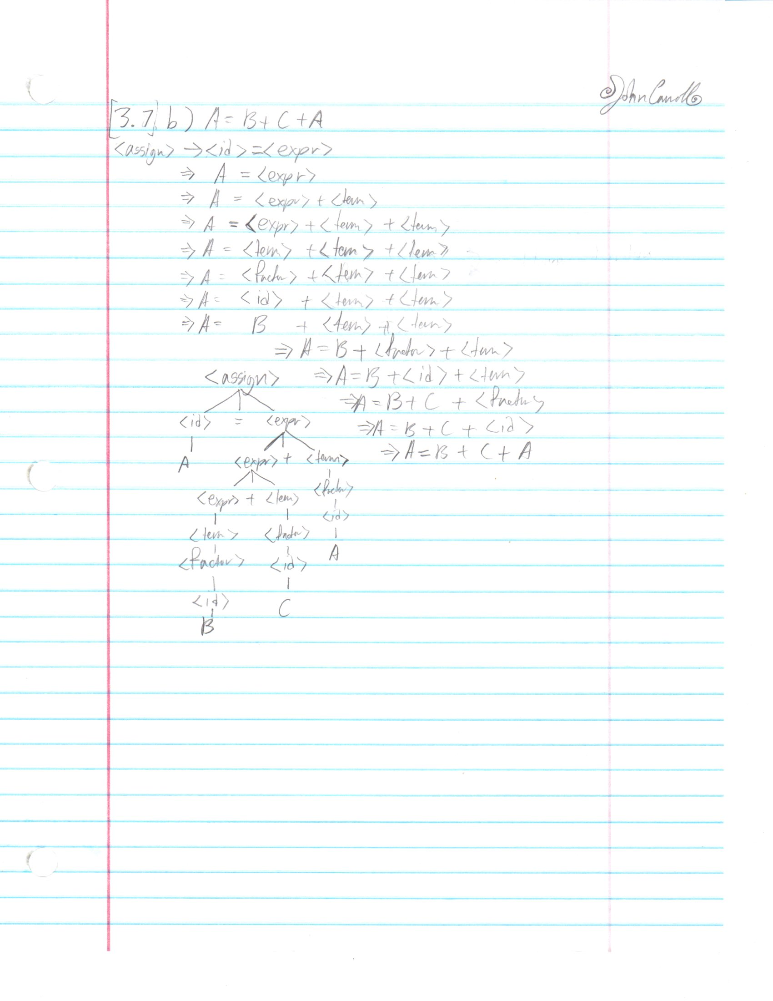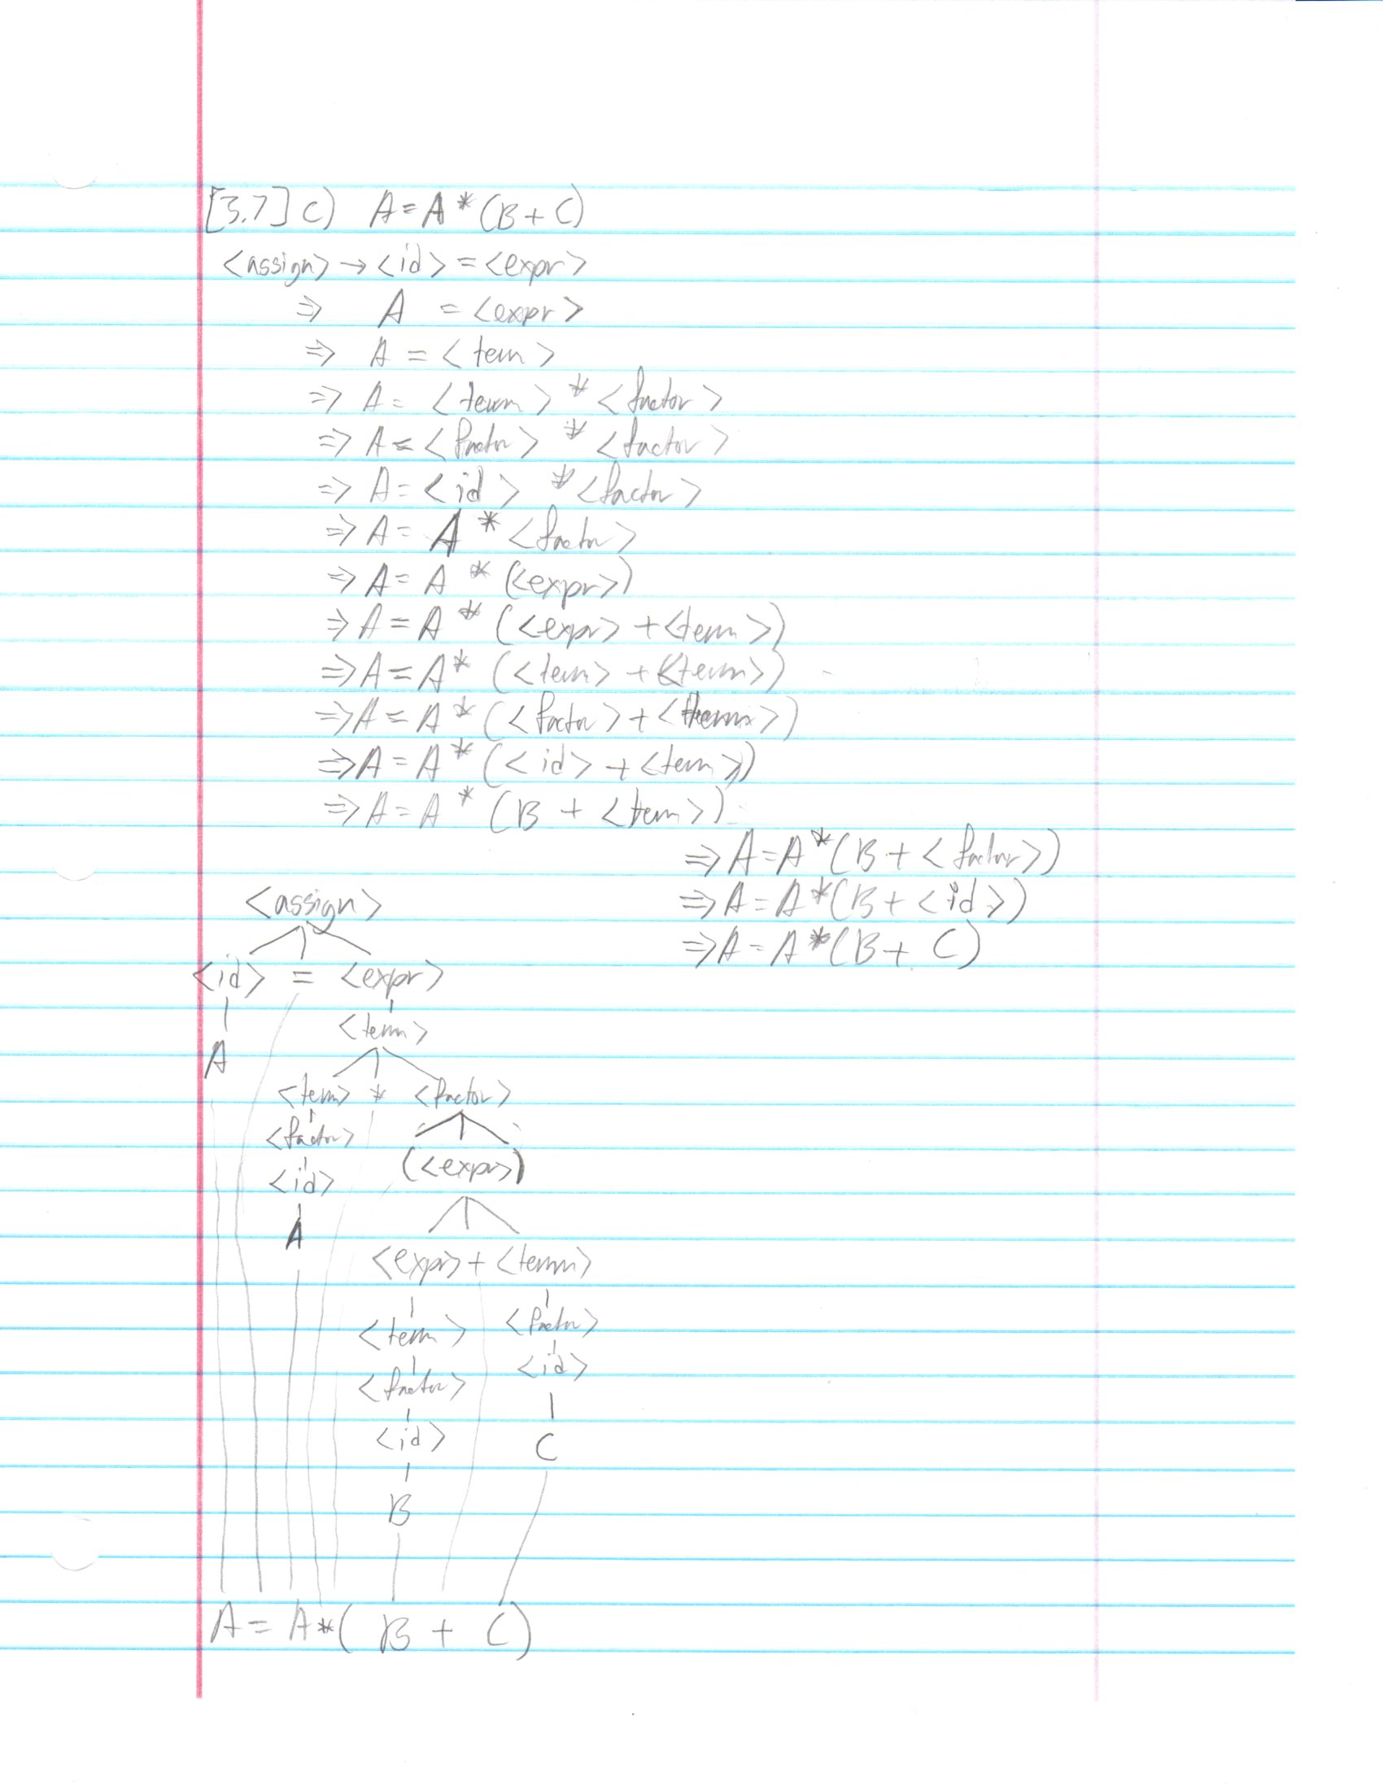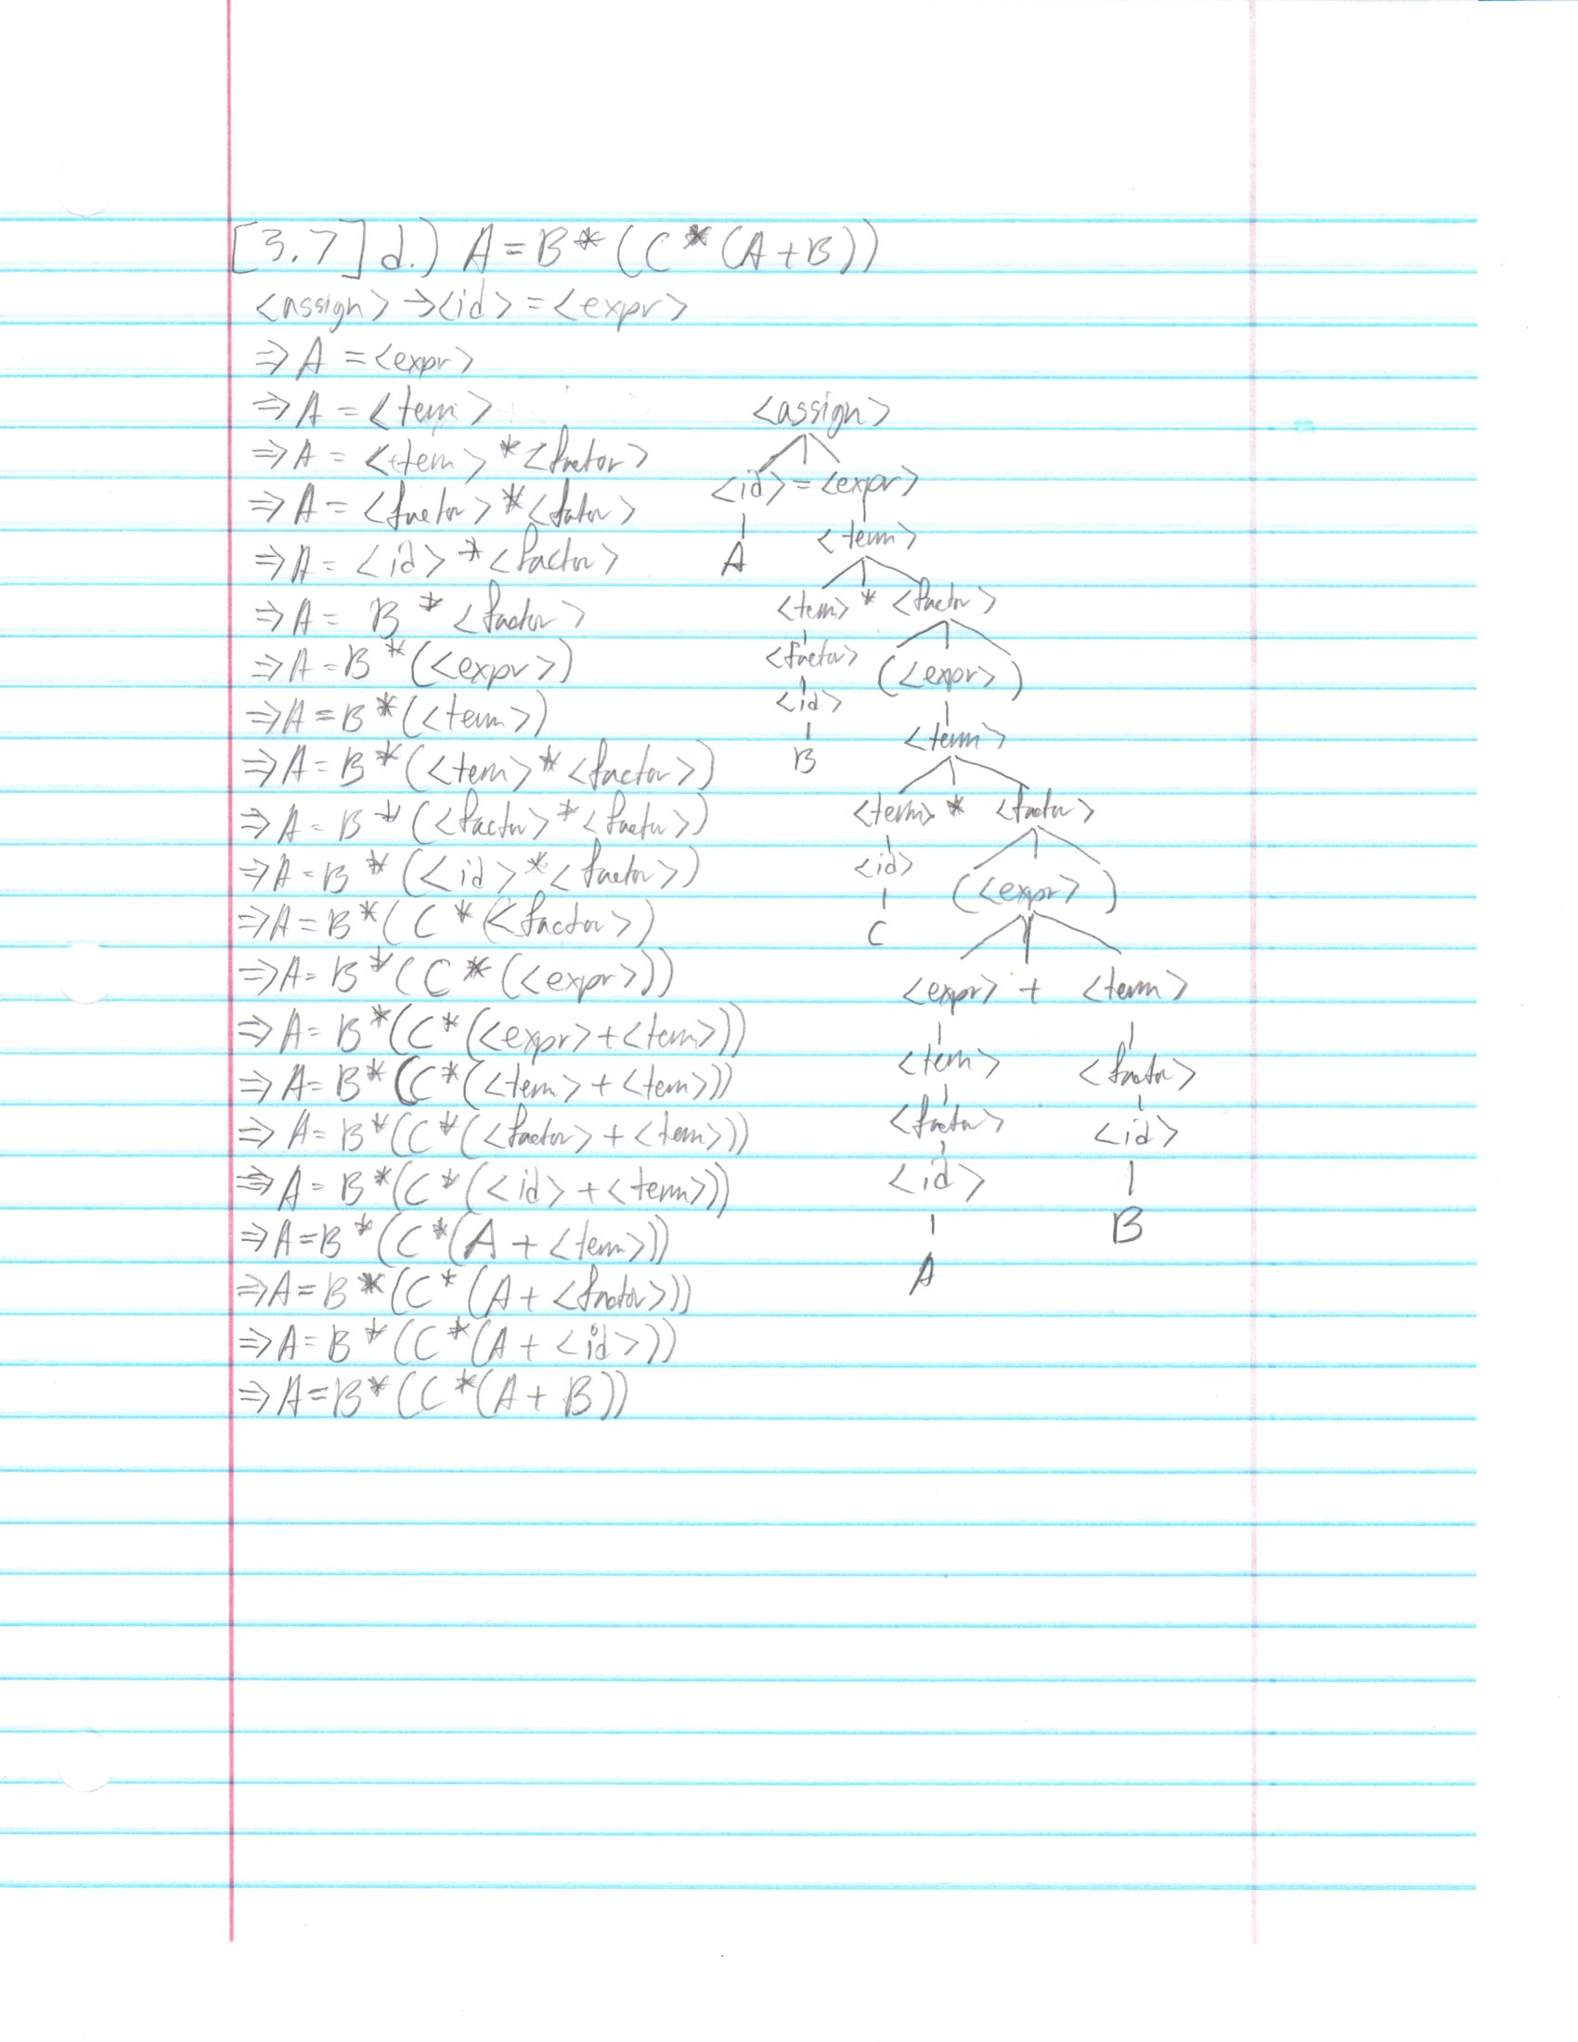

(2. 20pts) Question 3.8 (page 164) from the textbook.

The following two distinct parse trees for the same string prove that the grammar is ambiguous.

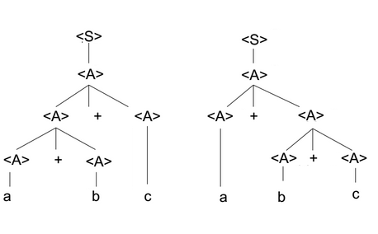

(3. 20pts) Question 3.11 (page 164) from the textbook.

<S> → <A> a <B> b   
<A> → <A> b | b   
<B> → a <B> | a

Which of the following sentences are in the language generated by this grammar?

1. baab - Yes
2. bbbab - No
3. bbaaaaa - No
4. bbaab - Yes

(4. 10pts) Question 3.13 (page 164) from the textbook.

Write a grammar for the language consisting of strings that have n copies of the letter a followed by the same number of copies of the letter b, where n > 0. For example, the strings ab, aaaabbbb, and aaaaaaaabbbbbbbb are in the language but a, abb, ba, and aaabb are not.

Ans: S → a S b | a b

(5. 20pts) Question 3.23 (page 165) from the textbook.

1. a = 2 \* (b - 1) - 1 {a > 0}

2 \* (b - 1) - 1 > 0

2 \* b - 2 - 1 > 0

2 \* b > 3

b > 3 / 2

1. b = (c + 10) / 3 {b > 6}

(c + 10) / 3 > 6

c + 10 > 18

c > 8

1. a = a + 2 \* b - 1 {a > 1}

a + 2 \* b - 1 > 1

2 \* b > 2 - a

b > 1 - a / 2

1. x = 2 \* y + x - 1 {x > 11}

2 \* y + x - 1 > 11

2 \* y + x > 12

(6. 10pts) Question 3.24(page 165-166) from the textbook.

1. a = 2 \* b + 1

b = a - 3 {b < 0}

a - 3 < 0

a < 3

Now, we have:

a = 2 \* b + 1 {a < 3}

2 \* b + 1 < 3

2 \* b + 1 < 3

2 \* b < 2

b < 1

1. a = 3 \* (2 \* b + a);

b = 2 \* a - 1 {b > 5}

2 \* a - 1 > 5

2 \* a > 6

a > 3

Now we have:

a = 3 \* (2 \* b + a) {a > 3}

3 \* (2 \* b + a) > 3

6 \* b + 3 \* a > 3

2 \* b + a > 1

b > (1 - a) / 2